**Paper 2 Revision F**

**Key topics to practice for 4th June**

**USE A CALCULATOR,**

**FIND A CALCULATOR,**

**USE A CALCULATOR**

All the topics listed below are likely to appear in some form in paper 2 or 3.

Give them a go, check your answers with the solutions provided and speak to your teacher.

**Very Likely topics**

|  |  |  |  |
| --- | --- | --- | --- |
| **Simplify Algebraic EXpressions** | **Area of shapes** | **Gradients, intercepts, y=mx+c** | **Time Calculations** |
| **Fraction, decimals and percenatges** | **Forming expressions / equations from context** | **Solve Linear Equations** | **Metric Units** |

**Likely topics**

|  |  |  |  |
| --- | --- | --- | --- |
| **Factors and Multiples** | **Types of Number 9odd, even, cube, prime)** | **Sequences (nth term)** | **Money** |
| **Probability** |  |  |  |

Very Likely Topic – Simplify Algebraic Expressions

**Q1.**

Simplify fully  2*x* + 9*y* + 1 + 8*x* – 5*y* – 7

_______________________________________________________________________

_______________________________________________________________________

_______________________________________________________________________

_______________________________________________________________________

Answer  _________________________

**(Total 3 marks)**

**Q3.**

Match each expression on the left with one on the right.

One has been done for you.

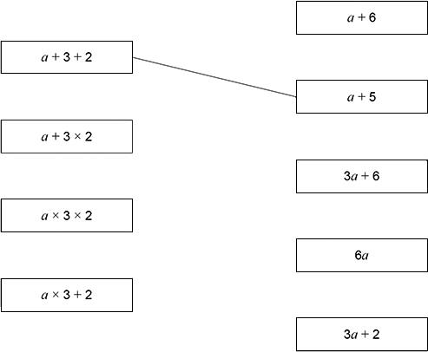

**(Total 3 marks)**

Very Likely Topic – Area of Shapes

**Q4.** Work out the area of this triangle.

Not drawn accurately

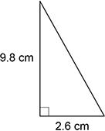

_______________________________________________________________________

_______________________________________________________________________

Answer ______________________________ cm2

**(Total 2 marks)**

**Q5.** Here is a shape made from rectangles.

Not drawn accurately

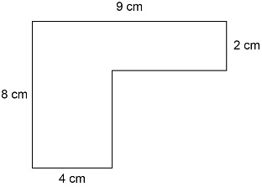

Work out the area.

_______________________________________________________________________

_______________________________________________________________________

_______________________________________________________________________

_______________________________________________________________________

Answer ______________________________________ cm2

**(Total 3 marks)**

**Q6.**

The rectangle and the triangle have the same area.

|  |  |
| --- | --- |
|  | Not drawn  accurately |

Work out the length of the rectangle.

_______________________________________________________________________

_______________________________________________________________________

_______________________________________________________________________

_______________________________________________________________________

_______________________________________________________________________

_______________________________________________________________________

Answer  ____________________ cm

**(Total 3 marks)**

Very Likely Topic – Gradients, Intercepts, y=mx+c

**Q7.**

A line has the equation  *y* = 3*x* − 5

(a)  Write down the gradient of the line.

Answer  ______________________________

**(1)**

(b)  Write down the *y*-intercept of the line.

Answer  ______________________________

**(1)**

**(Total 2 marks)**

**Q8.** Here is a graph of a straight line.

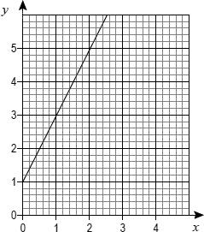

(a)  Work out the equation of the line.

___________________________________________________________________

___________________________________________________________________

___________________________________________________________________

Answer  _________________________

**(2)**

(b)  Work out the coordinates of the *y*-intercept of the line that

is parallel to the line in part **(a)**

and  passes through (2, 2)

___________________________________________________________________

___________________________________________________________________

___________________________________________________________________

Answer ( _______ , _______ )

**(2)**

**(Total 4 marks)**

**Q9.** Work out the gradient of the straight line through (–2, 3) and (1, 9)

_______________________________________________________________________

_______________________________________________________________________

_______________________________________________________________________

Answer _________________________________________

**(Total 2 marks)**

Very Likely Topic -Time Calculations

**Q10.** Times for the three parts of a journey are

•   20 minutes

•   40 minutes

•   1 hour 30 minutes.

Work out the **total** time for the journey.

Give your answer in hours.

_______________________________________________________________________

_______________________________________________________________________

_______________________________________________________________________

_______________________________________________________________________

_______________________________________________________________________

Answer ______________________ hours

**(Total 2 marks)**

**Q11.** Work out one quarter of 5 hours.

Give your answer in minutes.

_______________________________________________________________________

_______________________________________________________________________

_______________________________________________________________________

Answer _________________________ minutes

**(Total 2 marks)**

**Q12.** A TV series has ten episodes.

Nine episodes are each 50 minutes long.

One episode is 1 hour 42 minutes long.

Work out the **total** length of the series.

Give your answer in hours and minutes.

_______________________________________________________________________

_______________________________________________________________________

_______________________________________________________________________

Answer  __________  hours  __________  minutes

**(Total 3 marks)**

**Q13.**

Ali revises each day for five days.

On each of the first **four** days he revises from 5 pm to 8 pm

On the fifth day he starts revising at 1 pm

He finishes when he has revised for a **total** of 18 hours for the five days.

What time does he finish on the fifth day?

_______________________________________________________________________

_______________________________________________________________________

_______________________________________________________________________

_______________________________________________________________________

_______________________________________________________________________

_______________________________________________________________________

Answer _________________________

**(Total 3 marks)**

Very Likely Topic - Fractions, Decimals & Percentages

**Q14.**

Write  0.27  as a fraction.

Answer  ____________________

**(Total 1 mark)**

**Q15.**

Write    as a decimal.

Answer  ____________________

**(Total 1 mark)**

**Q16.**

Circle the fraction equal to 0.1%

                  

**(Total 1 mark)**

**Q17.**

(a)     Which **two** grids have one-quarter shaded?

|  |  |
| --- | --- |
| ***A*** | ***B*** |
| ***C*** | ***D*** |

Answer _______________ and ______________

**(2)**

(b)     What percentage of this grid is shaded?

|  |  |  |  |  |
| --- | --- | --- | --- | --- |
|  |  |  |  |  |
|  |  |  |  |  |

___________________________________________________________________

___________________________________________________________________

Answer _______________________________________ %

**(2)**

**(Total 4 marks)**

**Q18.** Before an election,

33% said they would vote for Party A

10% said they would vote for Party B

15% said they would **not** vote.

These all voted as they said.

In the rest of the population  voted for Party A and  voted for Party B.

(a)  Who got the most votes?

You **must** show your working.

___________________________________________________________________

___________________________________________________________________

___________________________________________________________________

___________________________________________________________________

___________________________________________________________________

Answer  _________________________

**(4)**

(b)  6600 people did **not** vote.

How many did vote?

___________________________________________________________________

___________________________________________________________________

___________________________________________________________________

Answer  _________________________

**(2)**

**(Total 6 marks)**

**Q19.** A gym has 275 members.

40% are bronze members.

28% are silver members.

The rest are gold members.

Work out the number of gold members.

_______________________________________________________________________

_______________________________________________________________________

_______________________________________________________________________

_______________________________________________________________________

Answer _________________________________________ **(Total 3 marks)**

Very Likely Topic – Solving Equations

**Q20.**

(a)  Solve   3*x* = 12

___________________________________________________________________

___________________________________________________________________

*x* = ______________________________

**(1)**

(b)  Solve   *y* + 6 = 15

___________________________________________________________________

___________________________________________________________________

*y* = ______________________________

**(1)**

(c)  Solve   

___________________________________________________________________

___________________________________________________________________

*w* = ______________________________

**(1)**

**(Total 3 marks)**

**Q21.**

Solve  4*x* + 1 = 39

_______________________________________________________________________

_______________________________________________________________________

_______________________________________________________________________

_______________________________________________________________________

_______________________________________________________________________

*x* = ______________________________

**(Total 2 marks)**

Very Likely Topic – Metric units

**Q22.** Write down a suitable **unit** of mass for an apple.

Answer  _________________________

**(Total 1 mark)**

**Q23.** (a)     Amir weighs a parcel.

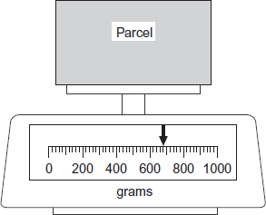

What is the weight of his parcel?

Answer _____________________________ grams

**(1)**

(b)     Beth has a parcel that weighs 1600 grams.

What is 1600 grams in kilograms?

Answer ___________________________ kilograms

**(1)**

**(Total 2 marks)**

**Q24.**

Circle the most suitable unit for each of the following.

|  |  |  |  |
| --- | --- | --- | --- |
| The length of a human finger | centimetres | metres | kilometres |
| The amount of water in a bath | millilitres | centilitres | litres |
| The weight of a pencil | grams | kilograms | tonnes |

**(Total 3 marks)**

**Q25.**

The diagram shows a woman standing beside a giraffe.

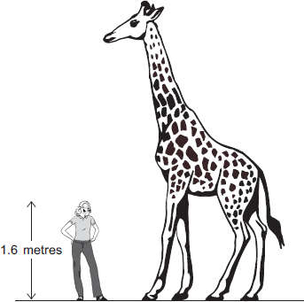

Estimate, in metres, the height of the giraffe.  
You **must** show your working.

_______________________________________________________________________

_______________________________________________________________________

Answer _____________________________ metres

**(Total 2 marks)**

Very Likely Topic – Forming expressions/equations in context

**Q26.**

The value of *A* is double the value of *B*.

Circle the correct formula.

*A* = *B* + 2       *A* = 2*B*              *A* = *B*2

**(Total 1 mark)**

**Q2.**

*e* is 3 **more** than *d*.

*f* is 5 **less** than *d*.

(a)  Write an expression for *e* in terms of *d*.

Answer _________________________________________

**(1)**

(b)  Write an expression for *f* in terms of *d*.

Answer _________________________________________

**(1)**

(c)  Work out  *e* − *f*

Simplify your answer.

___________________________________________________________________

___________________________________________________________________

___________________________________________________________________

Answer _________________________________________

**(2)**

**(Total 4 marks)**

Likely Topic – types of Number (odd, even, cube, prime…)

**Q27.**

Complete the boxes using

two **different** even numbers

and

two **different** odd numbers.

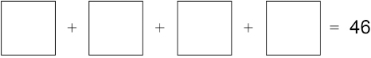

**(Total 2 marks)**

**Q28.**

The first two cube numbers are 1 and 8

Show that

the 3rd cube number can be written as the sum of three different prime numbers.



**(Total 3 marks)**

Likely Topic - Multiples and Primes

**Q29.**

Circle the number that is a multiple of 25

55       65       75       85

**(Total 1 mark)**

**Q30.**

Complete the boxes using

a factor of 12

and

a factor of 40

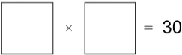

**(Total 2 marks)**

**Q31.**

Work out the multiple of 60 that is closest to 400

_______________________________________________________________________

_______________________________________________________________________

_______________________________________________________________________

_______________________________________________________________________

Answer _________________________

**(Total 2 marks)**

Likely Topic – Sequences (more likely nth term)

**Q32.**

(a)     Here is a sequence.

           5                8                11                14                17                .....

Write down the next number in the sequence.

Write down the rule for continuing the sequence.

___________________________________________________________________

Next number ___________________________________

Rule ___________________________________

**(2)**

(b)     Here is a different sequence.

Work out the *n*th term of the sequence.

                 7                13                19                25                31

___________________________________________________________________

___________________________________________________________________

Answer _________________________________________

**(2)**

**(Total 4 marks)**

**Q33.**

A linear sequence begins

2  5  8  11

Work out an expression for the *n*th term.

_______________________________________________________________________

_______________________________________________________________________

_______________________________________________________________________

Answer  ____________________

**(Total 2 marks)**

Likely Topic - Money

**Q34.**

One lettuce costs £1.29

How much do **seven** of these lettuces cost?

_______________________________________________________________________

_______________________________________________________________________

_______________________________________________________________________

Answer £  ____________________

**(Total 1 mark)**

**Q35.**

Five cucumbers cost £6.40 in total.

How much do **two** of these cucumbers cost?

_______________________________________________________________________

_______________________________________________________________________

_______________________________________________________________________

Answer £  ____________________

**(Total 1 mark)**

**Q36.**

An electric car uses 1 unit of electricity to travel 3 miles.

1 unit of electricity costs 50 pence.

Work out the cost of electricity, in pounds, to travel 270 miles.

_______________________________________________________________________

_______________________________________________________________________

_______________________________________________________________________

_______________________________________________________________________

_______________________________________________________________________

_______________________________________________________________________

Answer £  ____________________

**(Total 3 marks)**

**Q37.** Leema buys 2 metres of linen at £8.50 per metre.

She also buys 5 metres of cotton.

The **total** cost is £38

What is the cost of **one** metre of cotton?

_______________________________________________________________________

_______________________________________________________________________

_______________________________________________________________________

_______________________________________________________________________

_______________________________________________________________________

_______________________________________________________________________

_______________________________________________________________________

Answer £  ____________________

**(Total 4 marks)**

**Q38.** An ordinary fair dice is rolled ten times.

Here are the first nine results.

6  1  3  2  1  5  5  5  5

Write down the probability of getting a 5 on the tenth roll.

Answer  _________________________

**(Total 1 mark)**

Likely Topic - Probability

**Q39.** An ordinary six-sided dice is rolled 300 times.  
It lands on five 120 times.

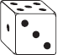

Do you think the dice is fair?  
Give a reason for your answer.

_______________________________________________________________________

_______________________________________________________________________

_______________________________________________________________________

_______________________________________________________________________

**(Total 2 marks)**

**Q40.** A bag contains only red counters and blue counters.  
 There are 6 **more** red than blue.

A counter is chosen at random from the bag.  
The probability it is blue is 

How many **red** counters are in the bag?

_______________________________________________________________________

_______________________________________________________________________

_______________________________________________________________________

_______________________________________________________________________

_______________________________________________________________________

Answer _________________________________________

**(Total 3 marks)**

**Q41.** Boxes A, B, C and D contain balls with numbers on them.

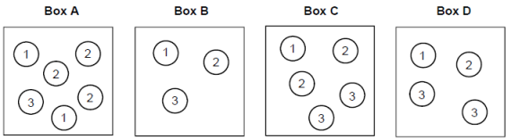

A ball is picked at random from each box.

(a)     Which box gives the **greatest** chance of picking a 3?

You **must** show your working.

___________________________________________________________________

___________________________________________________________________

___________________________________________________________________

___________________________________________________________________

Box ___________________

**(2)**

(b)     Which two boxes give the **same** chance of picking a 1?

___________________________________________________________________

___________________________________________________________________

Box __________________ and Box __________________**(1)**

**(Total 3 marks)**