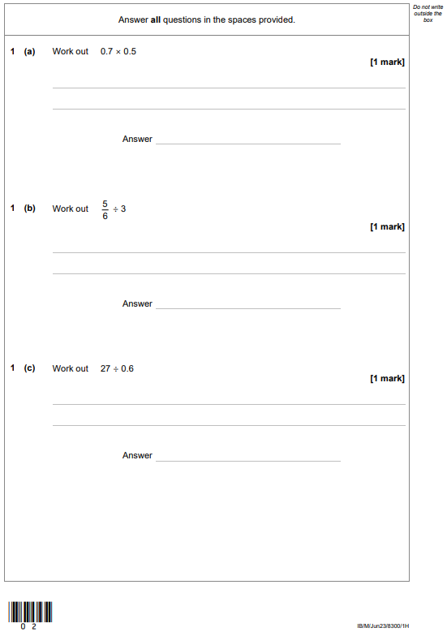

**Name:**

**Ultimate Practice Paper Revision**

**Summer 2023 Paper 1 Higher**



SUPER CHARGE YOUR REVISION!

Practice papers are far more useful when you…

* Complete a double page.
* Look at the worked solutions after every double page or look at the video solutions; whichever you prefer.
* For the questions/topics that you got wrong, look at the Sparx codes and build up your confidence.
* Have a go at the shadow paper and check your answers on the mark scheme.
* A shadow paper is very similar to the original paper

|  |  |  |  |
| --- | --- | --- | --- |
| Written Solutions | Video Solutions | Shadow Paper | Shadow Paper Mark Scheme |
|  |  |  |  |

Sparx Codes – Paper 1H 2023

|  |  |  |
| --- | --- | --- |
| Questions | Topic | Sparx Code |
| 1a | Using a written method to multiply decimals | U293 |
| 1b | Dividing fractions | U544 |
| 1c | Using a written method to divide with decimals | U868 |
| 2 | Solving single inequalities | U759 |
| 3 | Multiplying fractions, Converting between mixed numbers and improper fractions | U475, U692 |
| 4 | Angles on a line and about a point, Constructing and solving equations | U390, U599 |
| 5 | Finding prime numbers | U236 |
| 6 | Share amounts in a given ratio, Find fractions of amounts without a calculator | U577, U881 |
| 7 | Prime factor decomposition | U739 |
| 8 | Expanding single brackets | U179 |
| 9 | Graphs of reciprocal functions | U593 |
| 10 | Calculating the mean, Constructing and solving equations | U291, U599 |
| 11 | Venn diagrams with set notation | U748 |
| 12 | Use standard form with positive indices, Use standard form with negative indices | U330, U534 |
| 13a | Function machines with letters, Expanding single brackets | M428, U179 |
| `13b | Substituting into functions | U637 |
| 14 | Calculating Range, Calculating Median | U526, U456 |
| 15 | Congruent triangles, Angles on parallel lines, Understanding similarity | U866, U826, U551 |
| 16 | Solving simultaneous equations using elimination | U760 |
| 17 | Surface area of cylinders, Surface area of spheres, Writing and simplifying ratios | U464, U893, U687 |
| 18 | Estimating roots and powers | U299 |
| 19 | Using the product rule for counting | U369 |
| 20 | Solving simultaneous equations using substitution | U757 |
| 21 | Completing the square | U397 |
| 22 | Multiplying and dividing surds, Adding and subtracting surds | U633, U872 |
| 23 | Converting recurring decimals to fractions | U689 |
| 24 | Equations of parallel and perpendicular lines | U898 |
| 25 | Using the exact values of trigonometric ratios (Higher) | U319 |
| 26 | Find the circumference of circles, Use Pythagoras' theorem in 2D, Simplify surds | U604, U385, U338 |
| 27 | Calculate with speed, Add & subtract algebraic fractions, Divide algebraic fractions | U151, U685, U824 |

